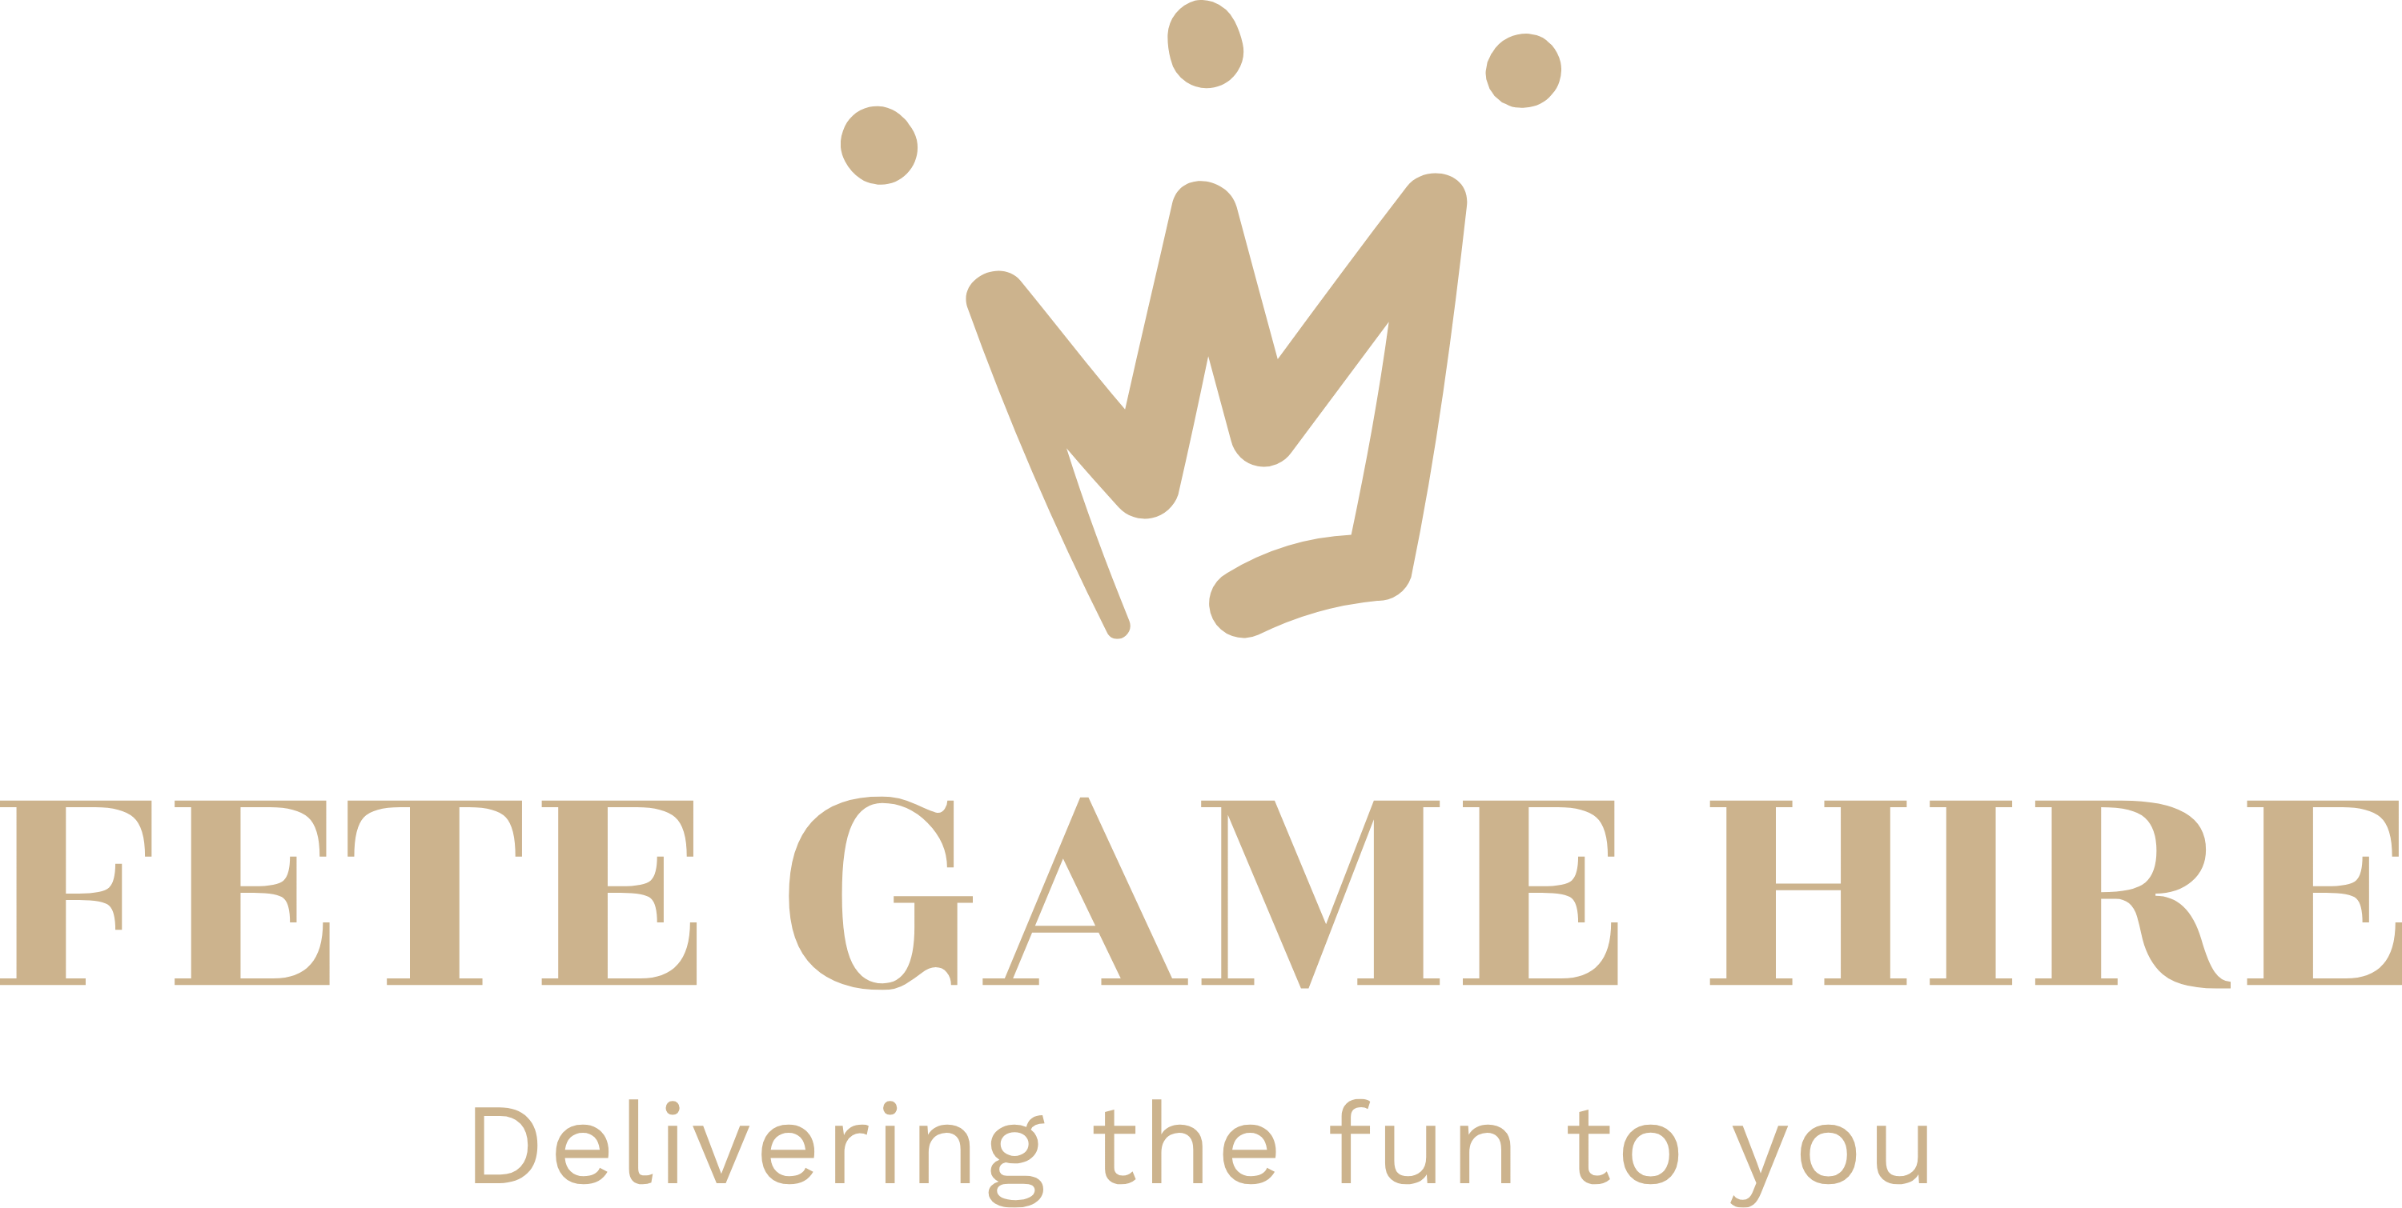

Terms & Conditions of Hire

- The standard working hours for Fete Game Hire (*FGH) events is:
September – March: 9.00am – 18.00pm April – August: 8.00am – 20.00pm
- An additional charge is incurred if the event exceeds these standard hours. If the hirer (the person who hires the games) requires the games or equipment overnight, then an additional charge will also be incurred at the time of booking. If the hirer has arranged for collection to be made the next day, it must be known that FGH may require access from 6am that morning, as items may be needed for another event that day.
- Bookings are NOT confirmed until the deposit or payment in full (if event is within 8 weeks) are paid and received. Bookings must be fully paid before an event can take place.
- Event bookings are only for 3 or 4 hours hire, dependent on the equipment required and location of the event, which will be confirmed during the booking enquiry stage. If the event timings exceed this, then the hirer can choose to pay extra for hire extension. Any delivery and collection charges will be quoted at time of booking and included in the full hire charge. Generators are hired in and therefore carry an additional charge, as do certain sundries such as coconuts. The hirer must discuss these when enquiring or booking.
- FGH are covered by £2.5 million public liability insurance as standard. Whilst this will insure that FGH are fully covered in the event of a claim against the Company for negligence or faulty equipment, this will not offer the hirer full protection against the hirer or event management. For larger events, involving the general public, it may be advisable for the hirer to take out their own insurance to protect them against unforeseen incidents. For private events, particularly where no manning is required or paid for, the hirer needs to arrange adequate insurance to cover damage or personal injury
- The hirer should be aware that most of our larger items will come with manning built into the price, although clarification on this can be obtained via our website or by phoning our office. If nothing is specified, yet manning is preferred, then this will incur an additional charge.
- If the games or other products hired are not manned by an employee of FGH, a fully refundable deposit may be charged in case of any damage caused to the hired items whilst they are the responsibility of the hirer
- For large scale and corporate events, FGH require the name of the insurance company and the insurance policy number prior to date of hire. If this is not given, the hire will be cancelled and no refund paid
- 50% deposit is payable on receipt of the first invoice after hiring. The remaining 50% is payable no later than eight weeks prior to the event date. BACs payments are also accepted, but no longer cheques.
- Cancellations for any reason are charged at 50% of the total booking costs up to 4 weeks prior to the event. Cancellations for any reason received within 4 weeks of the event date are charged at 100% of the total booking costs. This also refers to cancellations resulting in adverse weather or unsuitable set up conditions, as well as acts of God.
- The games and equipment are supplied by FGH in good working order. If a game or piece of equipment has to be withdrawn from a booking due to unforeseen circumstances, then FGH will liaise with the hirer (the person who hires the games) to discuss substitution, where possible. However, if this is on the day of the booking, we use best endeavours to provide a replacement. It is very difficult, during a 3 or 4 hour booking, to send someone to repair a game on site, during an event. Repairs must not be attempted by the hirer unless agreed by FGH.
- The hirer takes responsibility for the ongoing condition of the games whilst they are on hire, including performing regular safety checks on the equipment and how it is being used. FGH is not to be expected to move the location of games and equipment once an initial set up has been achieved. FGH staff must not be expected to carry or move heavy or awkward items too far from the van to the event location. If the hirer has any doubt, this must be checked at the time of booking. If it is discovered that, upon arrival at an event, unsuitable expectations are put on staff to carry heavy or awkward items too far, FGH’s office must be made known and it may result in those games or activities not being put out – in a situation like this, the hirer is not eligible for a refund.
- The hirer must understand that it may not always be possible to provide cover or protection for rain or wind. This may affect the operation of certain games and activities. The hirer may prefer to organise an alternative location if the weather is too bad. Refunds will not be provided in such a situation as it is beyond the control of FGH. If the event is on a large scale or has cost a considerable expense, the hirer may wish to consider event insurance to protect them against bad weather.
- Delivery and collection times are arranged with the hirer prior to the event. FGH is not accountable for any delays in arriving to an event that are due to traffic or other unforeseen issues beyond the control of FGH. Refunds will therefore not be given.
- FGH has risk assessments for all games and equipment. These can be sent to the hirer at any time, upon request. Any health and safety and insurance documentation can be provided to the hirer upon request. It is the responsibility of the hirer to carry out a thorough risk assessment of their venue, event planning and siting of FGH’s games and equipment and to ensure that the items hired comply with any health and safety regulations, company safety policies and/or conditions imposed by any official body
- From the time of delivery to the time of collection, the hirer is responsible for the safe working and custody of the equipment including, but not limited to, theft, vandalism and fire. The hirer is responsible for all damage and loss, howsoever sustained. The hirer will be responsible for total reimbursement to the owner at full retail prices if any loss or damage occurs. Upon completion of an event, just prior to FGH collection, it is the hirer’s responsibility to ensure that all items are gathered and ready. Any items that are lost or damaged will be invoiced accordingly to the hirer. This also applies to any game or equipment damage through public disorder and the misuse of alcohol, for which the hirer will be charged.
- It is the responsibility of the hirer to ensure there is suitable access for the delivery and set up of all games and equipment. At the time of booking, it is the hirer’s responsibility to ensure that matters such as access, siting, vehicle manoeuvrability, ground suitability are addressed. If FGH arrive to an event that is clearly unsuitable for the equipment, then that equipment will not be set out and no refund will be given. Many of the games, and large items like the Incredible High Striker require set measurements in order to be wheeled into position for an event. Others may need to be driven to the point of location and set up there. The hirer of these larger items must ensure that the vehicle towing them has room to drive into position and back out. If an inflatable or other game is required for an event, it is the hirer’s responsibility to ensure that there is enough space for the inflatable or game to be set up, along with space around to ensure optimum use. Please check website, but it is the responsibility of the hirer to liaise with FGH office staff if more information is required than shows on the website itself.
- The hirer is also responsible to making FGH aware of any issues that could prevent the set up and use of any games and equipment, including (but not limited to) sloped surfaces, holes in the ground, uneven or bumpy surface, steps, slopes, gravel surfaces, obstructions, parked vehicles, locked facilities, empty locations, crowded venues.
- The hirer needs to be aware of the suitability of an indoor venue and the games required, especially referring to, but not limited by, sizing and dimensions.
- For Candyfloss and Popcorn, it is the responsibility of the hirer to ensure that realistic portion or serving numbers are paid for prior to a booking. FGH needs accurate confirmations of numbers prior to the event to ensure adequate stock of popcorn and candyfloss supplies to cater fully. A power source will be needed close by, although the hirer can ask for an extension lead if the distance is further.
- Any faults or concerns during an event should be immediately notified to FGH staff.
- These terms and conditions are agreed at the point of signing the hire contract. The contract shall be governed by English law.

I have read, and understood the terms laid out above;

Signature; ___________________________ Name; _________________________________

Company; ___________________________ Date; _________________________________

